Cineplex is a leading entertainment and media company, headquartered in Toronto, Canada, and operates 164 theatres with 1,676 screens from coast to coast, serving approximately 77 million guests annually. It is a top-tier Canadian brand that operates in **the Film Entertainment and Content**, **Amusement and Leisure**, and **Media** sectors.

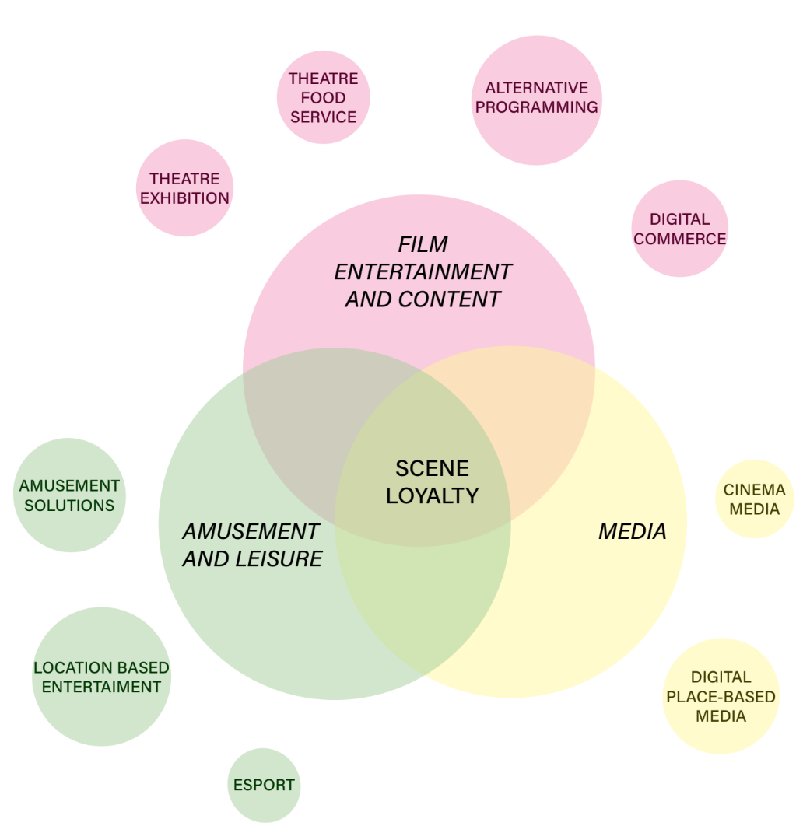

By reading the “Letter to Shareholders” from Chair of the Board Ian Greenberg, 2019 Cineplex remains confident in the company’s strategic direction to diversify beyond exhibition and expand core strengths into other entertainment and media offerings.

In order to understand better of Cineplex diverse of businesses, we designed Cineplex **Business model canvas** for our further analysis.

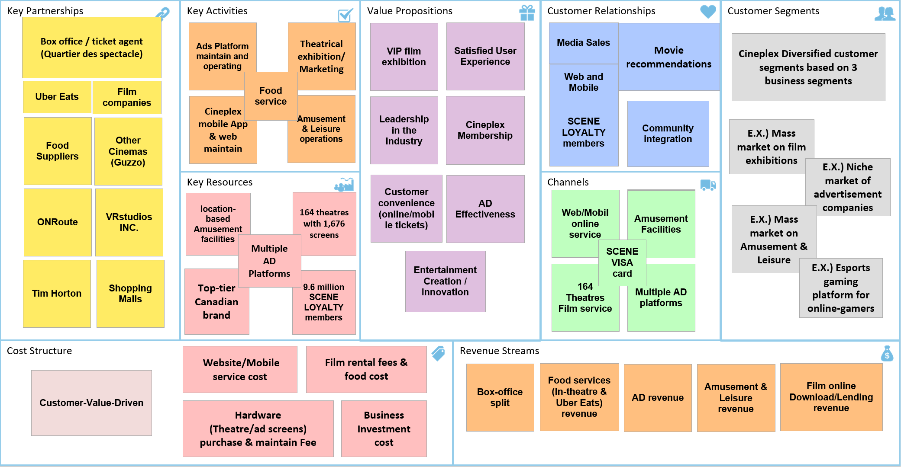

In 2018, Cineplex Total revenue increased 3.8% to $1.6 billion. Annual box office revenue increased 1.2% to $724.2 million. Theatre food service revenue increased 4.4% to an all-time record of $440.7 million. Media revenue decreased 4.0% to $165.0 million (due to lower cinema advertising). Amusement revenue increased 11.0% to $205.8 million (due to added revenue contributions from The Rec Room).

Data collected from Cineplex annual report 2018

The above bar chart can clearly see the revenue of Media segment is decreasing 4% while the other segments are all increasing in year of 2019. Let us have a further look into these 3 parts of business segments and have a general evaluation on each business strategy and results.

In Summary, Cineplex’s film exhibition business remains front and center in consumer consciousness. It is also undergoing with lots of high-tech hardware innovations. There are also data related innovations, such as newly launched Cineplex mobile App for online ticket booking, interactive Ads, SCENE loyalty program. Amusement and Leisure is under quick expansion since 2015 and the revenue is increasing very rapidly. Cineplex Media is the third segment which has a big potential capability to create new revenue. It is less mature than film business but more data than Cineplex Amusement.

Therefore, complied with company’s general strategies, fully understand of business model, analyzed the annual state of operation, considering existing data, we will focus on our initiative of **Increasing Media Revenue.**

**Strategic analysis**

Before conducting further analysis, we need understand more about Cineplex Media business and look into the existing data to guide us to make more accurate analysis and decisions. Cineplex’s media business covers two major categories: **Cinema Media**, which incorporates advertising mediums related to theatre exhibition and **Digital Place-based Media**.

1. ***Cinema Media - conducted in theatres.***

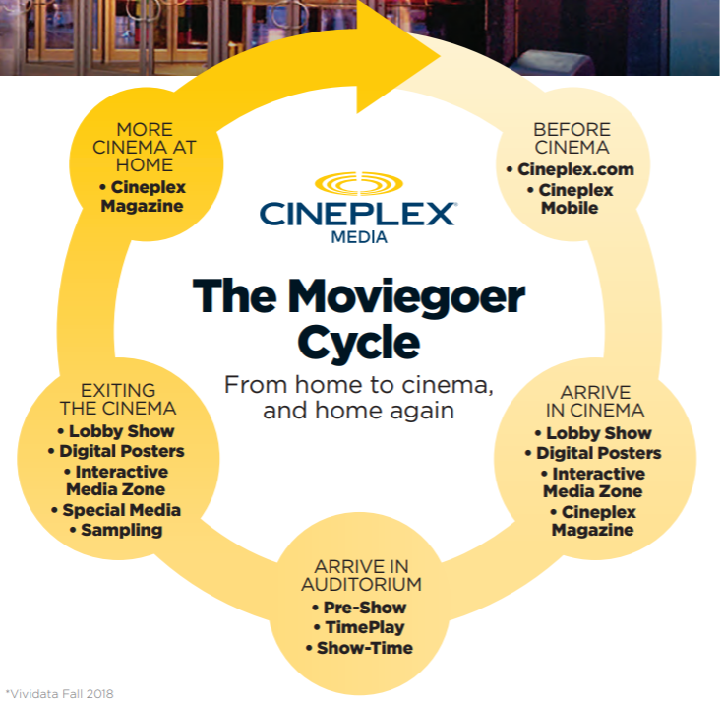

(CINEMA MEDIA KIT - WINTER 2019)

**There are 7 different properties for advertising content:**

|  |  |  |  |
| --- | --- | --- | --- |
| **Platform** | **Method** | **Advantage** | **Disadvantage** |
| **Show-Time** | Show-Time ad is placed just prior to the big, bold movie trailers in darkness | Most effective, zero distractions | Ad producing high requirement than TV  Expensive |
| **Pre-Show** | Pre-Show ad is placed before Show-Time ad in brightness | Very effective | Ad producing high requirement than TV  Less Expensive than Show-Time but Still expensive than others |
| **Cineplex TimePlay** | Download a game to smartphones and guests are competing the game online before the move starts and a real-time advertisement | Real-time ad directly to the phone, easy to measure the effective | More attractive to young ages, group relied |
| **Digital Cinema Lobby** | Larger than life and located in the highest-traffic areas  screens change color, the entire lobby changes color | Hard to miss  Fairly effective  Less expensive | Less attention than On-screen AD |
| **Interactive Media Zone** | Wall-to-wall consumer interactionsScreens utilize touch and motion, full audio play and record, video, and can connect with guests' mobile devices and link to their social networks. | Longer and vivid ad  that make guests to interact with brand  effective | High producing cost Only Available in 30 of theatresLow coverage rate |
| **Cineplex Magazine** | features exclusive interviews with many of Hollywood's biggest stars, beautiful photos, behind-the-scenes movies scoops and movie release schedulesReaders can pick it up in theatre lobbies or get it in their *Globe and Mail*. | 4.1 million readersthe most popular entertainment magazine in CanadaCanada's #1 magazine with readers age 14 to 54! | Effective only for certain group |
| **Online & Mobile** | Pop-up ad | average of 5 million unique unduplicated visitors per month | Low attention |

1. ***Digital place-based media – conducted out of theatres***

**There are 4 different properties for advertising content:**

|  |  |  |  |
| --- | --- | --- | --- |
| **Platform** | **Method** | **Advantage** | **Disadvantage** |
| **Shopping Centers** | Place ad at the mall (56 shopping centers) | deliver a huge opportunity to talk to your consumers within moments of their purchase decision | Effectiveness highly depends on the mall’s traffic patterns. |
| **ONroute** | Place ad in ONroute highway service facilities | ONroute built and designed for maximum comfort and relaxation for highway drives.  Under Relaxation, with higher attention on AD | Effectiveness highly depends on the highways traffic patterns and weather |
| **Tims Tv** | Place ad in Tim Hortons TVs | 24 hours ad playing on 2,500+ locations with wild range of consumers age from 14 to 65+ | Effectiveness also highly depends on Tim Horton’s Traffic patterns |
| **Concourse Network** | Place ad in food court | Ad can be refresh on time | Effectiveness rely on office worker during meal time |

After viewing lots of Cineplex’s Media details, we can describe a whole picture in our mind and it’s time to dig out the main chasms where we can apply data to assist improving. First, let us see below Theatre Attendance data and Media revenue data, it shows that Theatre Attendance is declining since 2015 and Cinema Media revenue has high correlation with Theatre Attendance while there is no linear correlation with Digital place-based media. This insight is also accord with our cognitions. The more attendance in the Theatre to see a film, the more advertising market will be.

(Data collected from Cineplex Annual report 2013/2014/2015/2016/2017/2018)

Thus, we think about increasing Media revenue by **increasing Theatre’s Attendance.**

* Optimize Theatre Row Piece Rate
* Optimize Film ticket price
* Continue increasing Membership for better customer targeting
* Optimize Food price
* Creative promotion solutions

On the other hand, we think about increasing Media revenue by **attracting more Advertising companies.**

* Maximizing AD effectiveness
* Competitive AD price

Next, let’s identify and prioritize Data Sources:

* Theatre Row Piece Rate
* Ticket price
* Membership database
* Food price
* Ticket Transactions
* Theatre Demographics
* Competitive Cinema promotion solutions
* Weather
* Traffic patterns
* Cineplex Mobile App
* Cineplex Web
* AD effectiveness

Then, we need assess the potential business value of the different-data sources vis-à-vis the identified use cases.

|  |  |  |  |  |  |  |  |
| --- | --- | --- | --- | --- | --- | --- | --- |
| **Data Sources** | **Optimize Theatre Row Piece Rate**  **A** | **Optimize Film ticket price**  **B** | **Continue increasing Membership for better customer targeting**  **C** | **Optimize Food price**  **D** | **Creative promotion solutions**  **E** | **Maximizing AD effectiveness**    **F** | **Competitive AD price**  **G** |
| **Theatre Row Piece Rate** |  |  |  |  |  |  |  |
| **Ticket Price** |  |  |  |  |  |  |  |
| **Membership database** |  |  |  |  |  |  |  |
| **Food Transactions** |  |  |  |  |  |  |  |
| **Ticket Transactions** |  |  |  |  |  |  |  |
| **Theatre Demographics** |  |  |  |  |  |  |  |
| **Competitive Cinema promotion solutions** |  |  |  |  |  |  |  |
| **Weather** |  |  |  |  |  |  |  |
| **Traffic patterns** |  |  |  |  |  |  |  |
| **Cineplex Mobile App** |  |  |  |  |  |  |  |
| **Cineplex Web** |  |  |  |  |  |  |  |
| **AD effectiveness**  **(no data on hand)** |  |  |  |  |  |  |  |

Then, we need do the implementation feasibility assessment

|  |  |  |  |  |  |
| --- | --- | --- | --- | --- | --- |
| **Data Sources** | **Ease of Acquiring** | **Cleanliness** | **Accuracy** | **Granularity** | **Cost** |
| **Theatre Row Piece Rate** |  |  |  |  |  |
| **Ticket Price** |  |  |  |  |  |
| **Membership database** |  |  |  |  |  |
| **Food Transactions** |  |  |  |  |  |
| **Ticket Transactions** |  |  |  |  |  |
| **Theatre Demographics** |  |  |  |  |  |
| **Competitive Cinema promotion solutions** |  |  |  |  |  |
| **Weather** |  |  |  |  |  |
| **Traffic patterns** |  |  |  |  |  |
| **Cineplex Mobile App** |  |  |  |  |  |
| **Cineplex Web** |  |  |  |  |  |
| **AD effectiveness** |  |  |  |  |  |

The last step is the Prioritization Matrix

1. Optimize Theatre Row Piece Rate
2. Optimize Film ticket price
3. Continue increasing Membership for better customer targeting
4. Optimize Food price
5. Creative promotion solutions
6. Maximizing AD effectiveness
7. Competitive AD price

Business

Value

|  |  |
| --- | --- |
| G | F  E  C  B |
|  | D  A |

Implementation Feasibility Hi

After using uncle Bill’s Big Data Strategy Document, we are now focusing on **Creative promotion solutions** and **Maximizing AD effectiveness** two strategies and we try to obtain more specific and solid solutions by using **SWOT analysis.**

|  |  |  |
| --- | --- | --- |
| **Internal** | **Strength** | **Weakness** |
| * **High market share on theatre industry, it is Canada’s largest Film Exhibitor.** * **Gold class film service offers a unique User experience. (Most advancing hardware, variety of food, online tickets, etc.)** * **Convenient Locations** * **Diversified business** * **Strong Profitability support Cineplex to have sustainable innovations** * **Loyalty membership to retain repeat customer** | * **High level of ‘red tape’ to clarify from authorities** * **High investment on Amusement recent years, circulating fund is on a low level to against risk** * **Difficulty in attracting new customer to increase traffic in theatre business** * **No digital platform for advertisement companies** * **Some theatres with Traffic congestion or lack of supporting facilities (Lack of restaurants and shopping malls, etc.)** |
| **External** | **Opportunities** | **Threats** |
| * **High entertainment requirements from consumers, which provide a broad potential market to develop** * **Increased Disposable Income** * **Low market competition** * **The preference of film is becoming various, such as import movies from Asia, operatic movies and this change may provide more potential customers** | * **iTunes, Netflix, on-line streaming (Film & TV shows) can lead to lower sales.** * **Weather conditions (Special in Winter in Canada)** * **High Entertainments Taxes** * **Restrictive Licenses if the ‘red tapes’ are not approved by authorities** * **Policy restrictions (Alcohol restrictions, Movie screening licensing, parking numbers restrictions)** |

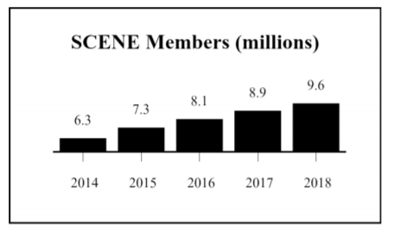After SWTO analysis, we can see that Cineplex had done a diverse of innovation in film entertainment. In order to increase attendance, it had created 4DX & ScreenX customer experience-based cinema hardware upgrades, it increased the food menus, VIP services and use BIG EVENTS by month, etc. However, with the digital movies and streaming online platform’s strong competition, Netflix the most competitor to Traditional Theatres, it attracts abundant of customers from cinemas to home with bigger convenience and less price. Internally, Cineplex also conducts a loyalty membership strategy for years, from below SCENE Members data, we can see, membership is processing pretty nice, from 2014 to 2018, it has already attracted 3.3 million members, which is only done in Canada. That means every 10 people, one has Cineplex membership card. Nevertheless, my question is, in this case, why the attendance is still dropping? It has big relationship with the BIG EVENTS, the most effective booster for cinema business, every month, there is main film to be promoted, online, in cinema’s lobby with life-sized cardboard, on cineplex website with dramatic big poster to attract its customers. It works, and it works effectively, if you see the films elected are most from Disney animations or Hollywood Hero/science fiction films. Majority of people think only BIG movie is worthy to be watched in Cinema with ticket plus food. Take Star Wars for instance, it has 4% attendance of the whole year while after Star Wars, the Q3, there is very low attendance in the whole quarter. So, despite how accurate your recommendation is, Cineplex loyal members still prefer staying at home, watching a film from Netflix, cheaper and convenient.

**Under such situation, our first suggestion is: FREE MOVIES if you watch Ads on your smart phone.** People only do very simple steps can get a free ticket, that will be a big motivation. It will be increasing more Mobile App downloads and bring more attendance in the cinema. Even with a 0 box-office, but it will be increasing food revenue and, in the meantime, it will attract more theatre-based Advertisement. Cineplex only need very limited cost on this strategy.

Moreover, let’s see Media business itself. Cineplex Media has very much the most advancing technology and broad coverage of media terminals for advertising companies. However, there is only a website to get information of different Media offerings but no integral digital platform for advertisement companies to decide fast and accurately AD placing strategy and monitoring AD real time audiences. There is Cineplex App only focus on film download and ticket booking, while there is no mobile app to assist Media Business. If you are an advertising company, today, you want to know about the price of each properties, where is the best located screen for your AD contents, you want to know what is the best time for your content. The only answer you will get is by call or email or go to Cineplex Media to find their Marketing representative to talk with you, finding out your demands, your AD budget, your AD products, then sales person will give you an experienced suggestion. It takes time, lack of accuracy, it increases customer’s risk and cost but also harmful for Cineplex long-term loyalty strategy. Thus, **our second suggestion is: Build up an integral DIGITAL PLATFOM for Media offering consultations and Ads monitoring.**

Solutions are proposed, however before it is executed, we need evaluate these two solutions and make sure they are creating values, financially profitable, technically realizable and risks are controllable.

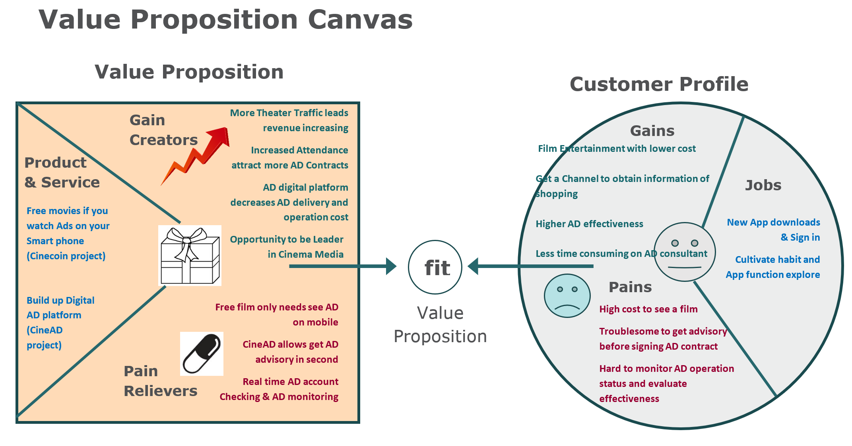

**ROI analysis**

**Value increased:**

|  |  |
| --- | --- |
| **More Theater Traffic leads film segment revenue increasing, including**  **(Food revenue, theater-based amusement consuming)** | Each year average 700,000 attendance and average 3.9 film per person, so actual viewer quantity is 179,000 and we can hope the free ticket mostly generated in these movie fans, and each fan has yearly 1.5 free tickets. So, the estimated increasing of attendance is 287,000 and based on the rate of food consuming, we can expect food increasing revenue will be approximately **180.82 million**. |
| **Increased Attendance attracts more AD Contracts revenue** | As per the rate of theater attendance and theater-based Media revenue, we canexpect **30.67 million** ADs revenue increasing. |
| **Integral AD digital platform creates new AD Contracts** | The AD effectiveness increasing and AD business operation and management convenience can greatly enhance the Loyalty of customer, it will be increasing repeat business and long-term business scale. Here we take 1-year operation hypotheses, we can expect 30% increasing based on 2018 Media revenue: 165 * 30% = **49.5 million** |
| **Decreased labor and operation cost** | Currently, the Media business service mostly is off line and based on traditional consultation, contract management and AD effectiveness evaluation. Once the digital platform built up, Media price, location, where to place Ads and How much people had viewed my AD contents all can be all done on line with real time processing ability. Operation cost could be dramatically decreasing on Sales / Marketing dept. We can expect 25% cost down based on last year’s Costs of operations 1492800 * 25% = **3.75 million** |

**Investment cost:**

|  |  |
| --- | --- |
| **Hardware purchasing cost (wireless + waterproof + day& night camera purchasing, price $78.99 each)** | There are 164 Theatres, each Theatre should install at least 1 camera at entrance. There are total 56 shopping center with total 652 Media terminals, thus each terminal need installs 1 camera. There is no need to install camera in Tim Horton and ONroute, since the Ads placed on TV screens, which has already data collected from wifi. Therefore, the total cost will be $78.99 x816 = **$83792** |
| **Software purchasing cost: Google Map + Google cloud** | **Google Map price** is based on clicking times, estimated clicking won’t be too large at the first three month, $100 per month, **$1200** per year.  **Google cloud price:** $14/camera *816*12= **$137088 per year** |
| **Software developing cost** | It needs normally 10 software developer, estimated salary 100,000 * 10 = **$1000,000** |
| **Internal training cost** | Training program for these two projects App training, we can estimate employee = 13000 total employee * 15% (Media share) *0.5 =975 employees 975*7h*$20= **$136,500** |
| **Food cost** | As per above estimated traffic increasing is 195000, food increasing 122.77 million, food cost is almost 25% = **30 million** |

|  |  |
| --- | --- |
| **Attribute** | **Cineplex whole organization** |
| **Benefit** | 180.82 million+30.67 million+49.5 million+3.75 million = **264.74 million** |
| **Investment** | $83792 + $1200 + $137088 + $1000,000 + $136,500 + 30 million = **165.85 million** |
| **Net Present Value (NPV)** | **98.89 million** |
| **Return on Investment (ROI)** | **60%** |

**Soft benefits:**

Free movies by watching Ads on smart phone, it is more business intelligence strategy, and targeting Ads by recommendation to customer is not a creative data strategy either. However, Cineplex needs this strategy to collect a huge user’s data, which is a key benefit of this project.

**Risks and challenges**



Data challenge:

It is a big challenge of obtaining the History Data from AD companies regarding the advertisement effectiveness.

They may have concerns of data privacy and also the evaluation of AD effectiveness is complicated itself, they may also lack of accurate data.

The Big data infrastructure may not be optimized, it may cause low performance and high cost and security vulnerability.

Cost challenges: The estimated cost of Google Cloud is not very accurate because it is hard to estimate the data volume of receiving and calculating by real time processing model.

Solution:

Create a win-win business model.

A digital AD platform will benefit AD company themselves. They provided data and Cineplex will use data to provide more effective AD placing strategies for AD companies.

Solution:

There is free trial from Google Cloud. We may install few cameras at the very beginning of the project and to see the actual cost of real time image processing.

Solution:

Need more communication with IT team and data architecture in order to make sure the data infrastructure is realizable.

**Projects operating details, data infrastructure and HR**

1. **FREE MOVIES if you watch Ads on your smart phone**: **Cinecoin project**

 Watch Ads (Ads auto-targeting, recommendation Model)

**  **

Answer questionnaire / Post comments of Ads they watched

User

Cinecoin mobile App

Get paid by Cinecoin

Cinecoin

Users use Cinecoin to buy film tickets

* Users sign in to Cinecoin mobile Appwith basic information: First name / Last name / Gender / Age / City / Country / Job Industry / Status / If have child / interests ect.
* Users log in to Cinecoin Mobile App, there will be a questionnaire pops up. It posts few questions such as: List 3 things you want to buy recently; do you have travel plan? What is your favorite sport, etc. Then system targets AD videos to different users. It is mapping user’s information with advertised products, thus reaching the most potential purchasing. Users are allowed to skip the Ads they are not interested in. However, when the video being watched, it can’t be mute and switched to the backend, which is invalid for system calculating the watching time. And if you are interested in some Ads contents, users can write comments under that Ad and gain extra Cinecoins.
* User get paid by Cinecoin based on the watching time & comments they provided. (Calculate Cinecoin as per AD Conversion Rate and film ticket price)
* User can use Cinecoin to buy film tickets then.
* Notes: System targets Ads by user’s basic information, questionnaires provided at the very beginning, with the time by collecting more data, it will take also their comments, searching records as data sources.

1. **Build up an integral DIGITAL PLATFOM for Media offering consultations and Ads monitoring: CineAD project.**

Google cloud

Real Time ADs

Real time traffic Image processing



Ads effectiveness machine learning

Data warehouse

ADs Consultant

CineAD

Data LakeAds Placing solution (machine learning)

My ADs

* Advertising companies Sign In CineAD with basic information: Company name / Address / Regested Capital / CEO name / Contactor name / Contact Phone# / Email / Main AD products etc.
* Once advertising company Log In CineAD Web / Mobile App, there are 3 services: Real Time Ads, Ads Consultant and My Ads. **Real Time Ads** can show generally all Cineplex AD operation dashboard, including the Media location (in-theater & out-theater facilities), Real time Attendance or Real time Traffic (Using Google Cloud & Google Map).

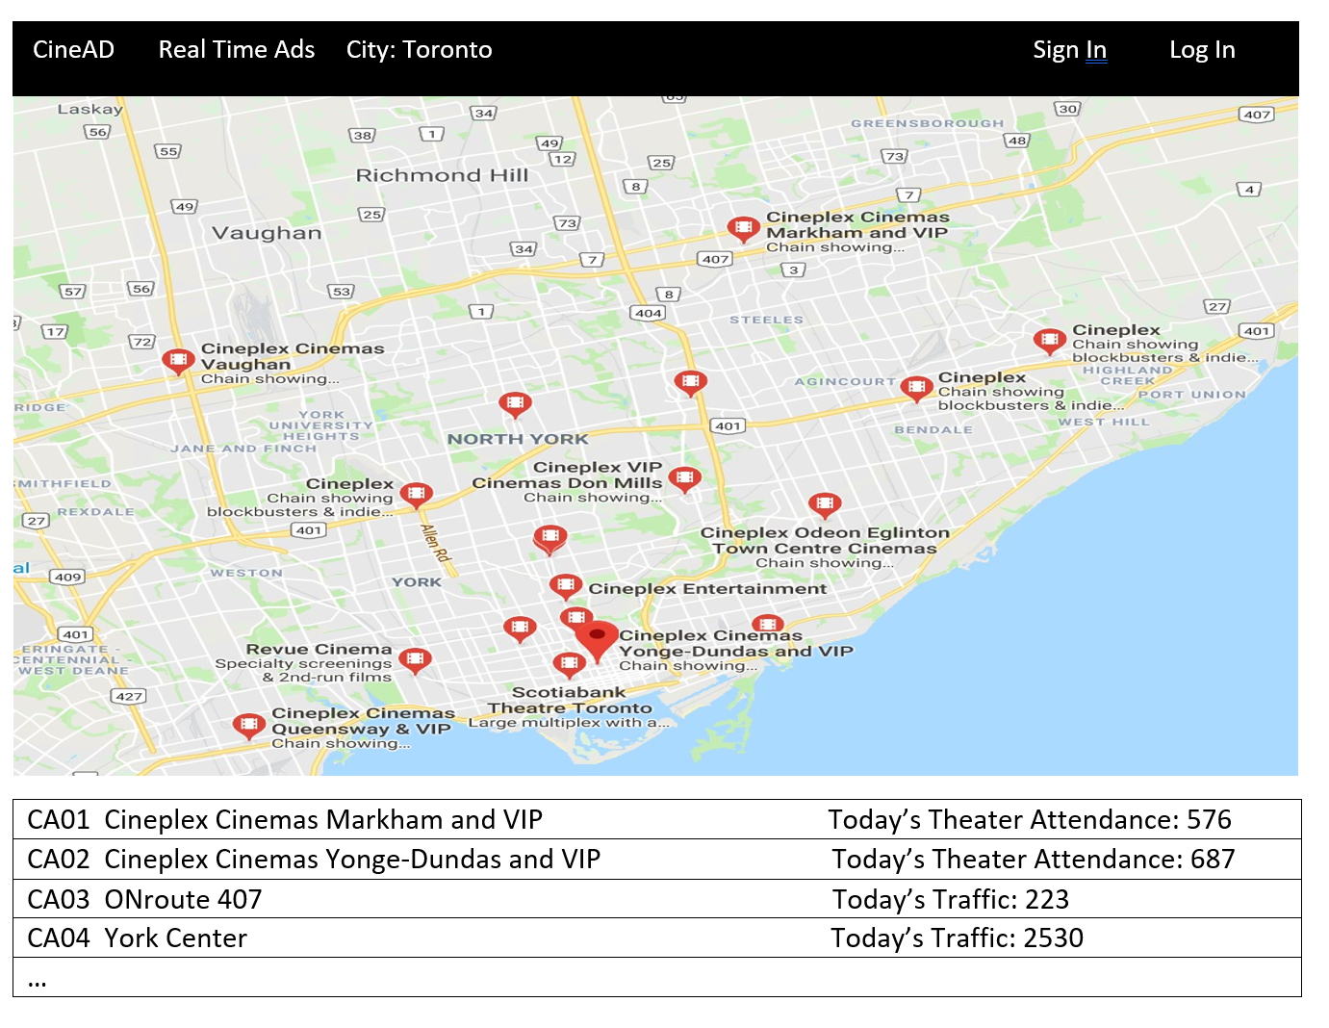

Partial sun Click one of the Media Terminal, it will show Media terminal (theater-based) as below:

**Cineplex Yonge-Dundas and VIP Date: July 4, 2019 Temperature: 32**

**Address**: 2125 Yonge street **Local events: Canada Day**

Today’s Theater Attendance by now: 753

And it will show as below if media terminal is our-door:

And, it will show Media terminal (outdoor-based) as below:

Partial sun

**ONroute 407 Date: July 3, 2019 Temperature: 32**

**Address**: 201 highways **Local Events: Canada Day**

Today’s Traffic by now: 223

* **Ads Consultant** can assist AD companies to taget Media channels in order to have most AD effectiveness. It requests to enter AD budget, AD product type, AD consumers group, AD type (text, picure or viedo), if viedo, what is the quality and tech etc. Then Ads Consultant can provide TopN recommendations based on Ads effectiveness machine learning module.
* AD companies can use **My ADs** to monitor their ADs operation status and account status.

Use below as an example: Once you enter My Ads, it will list all the contracted Ads as below:

CineAD My Ads Sign In Log In



Click HEINZ for example, system will provide all the media teminals for this Ads.

CineAD My Ads Sign In Log In

|  |  |  |  |
| --- | --- | --- | --- |
|  | **Cineplex Cinemas Markham and VIP** | **Theater Pre-show**  Play time: July 1 – Aug 30  Play calculation by times | Film connected: Lion King  Film connected: Dora  **Total attendance by today: 11425** |
|  | **Cineplex Cinemas Markham and VIP** | **Theater Lobby Digital video**  Play time: 2pm – 10pm rolling playing  (July 1 – Aug 30) | Total visitors from 2pm – 10pm: 27580  Interval playing time: 3mins  **Virtual visitors: 9193** |
|  | **York Center** | **Shopping mall digital Ad**  Play time: 5pm – 9pm  Rolling playing  (July 1 – Aug 30) | Total Traffic from 5pm – 9pm: 36500  Interval playing time:  5mins  **Virtual Traffic: 7300** |
|  | **Cineplex Mobile App**  **Cinecone Mobile App**  **Cineplex web** | **Pop-up Ad**  **Play time: (July 1-Aug 30)** | **Total view times: 258101**  **Comments times: 123**  **Comments file download** |

**Data infrastructure:**

**Software:** Data warehouse (using current one),Hadoop eco (Data lake + computing), Real-time Data processing platform (Google Cloud), google map (API)

**Hardware:** Cameras installing on AD terminals & Theater lobbies

IoT (Film screens, cameras, media terminals), web app, mobile app, logs, Google Map, RDS (ERP, CRM…)

 Business data

  Log message (Kalfa)

Distributed Storing & Computing platform

HDFS

Hbase

Hive

MapReduce

JAVA, Perl, C, C++, Python

PIG

Mahout

HQL

E

T

L

Data Warehouse

BI system

Ads targeting system

(Cinecoin)

Ads Consultant

(CineAD)

Ads Account Management

(CineAD)

Log backup

Real-time Processing

Real time dashboard

Data Sources

Data Mart

**Data Team structure:**

(1 Head of Data Science / 1 Lead Data Scientist / 2 Data Engineers / 1 Product Developer / 1 Data Scientists / 1 Data Analysts)

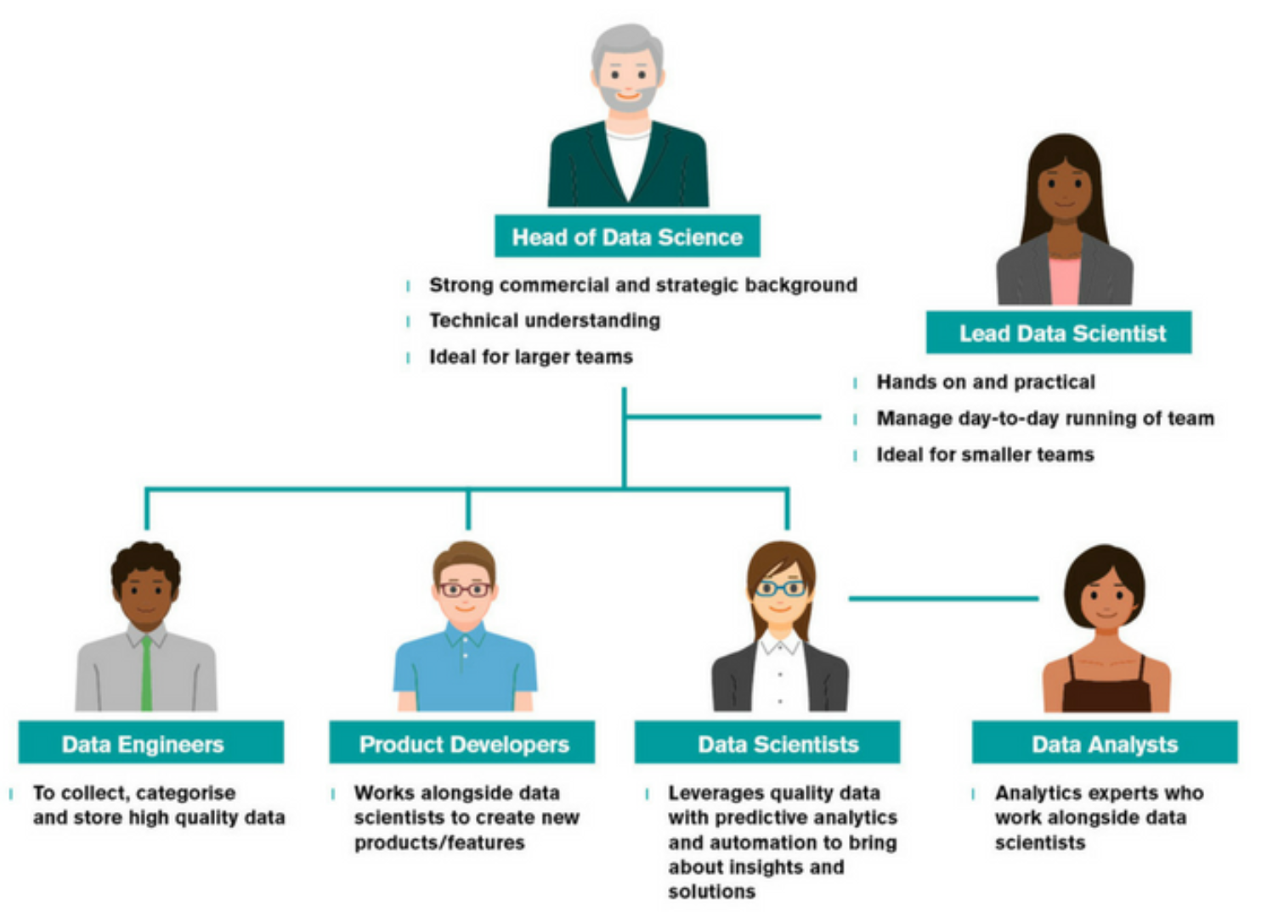

**Road Map:**

We are planning 14 months developing time for both projects. Below is only a screen shot for your sketchy understanding. The full roadmap is attached in xlsx format.****

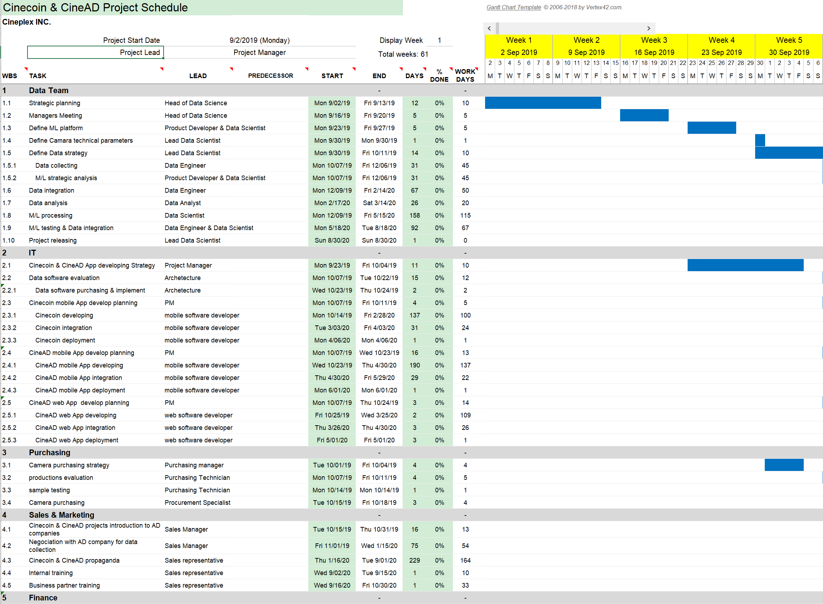

**Legal and ethical aspects**

Business profit and Social responsibility, which one is more important? We think both are very important and we need to balance the business activities with Legal & Ethical consideration. Illegal and Unethical, we will definitely say “No” and this is the red line of data using principles. The Legal but Unethical & Illegal but Ethical parts are somehow like a grey zone, we may touch it but always in good purpose. And we all believe the more Legal & Ethical activities we are doing, longtermly, it will maintain a high reputation of Cineplex.

**Legal**

**Legal & Ethical**

**Legal but Unethical**

Protect the privacy of the customers and won’t share data with another stakeholder

Protect consumer’s portraiture rights (image took from the camera)

Use information only for what we want to disclose the purpose

Set up Data protection officer and limits of authority of obtaining data

Accept Ads with Discriminatory content

Ads targeting with discriminatory Intent

Data collection & cleansing by some biased hypotheses

**Ethical**

**Illegal and Unethical Illegal but Ethical**

Place cameras on remarkable points and disclose to people.

Obtain shared AD effectiveness data from AD company but only use data for benefiting advertiser purpose

Sell customer’s information without their permission

Place cameras in hidden place